Data entry, import, and basic organization using tables

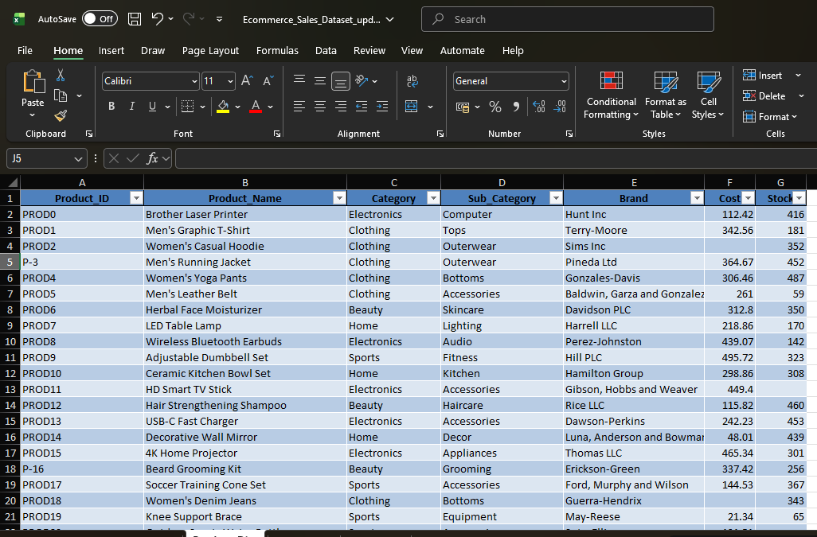

DATA CLEANING:

find/remove duplicates

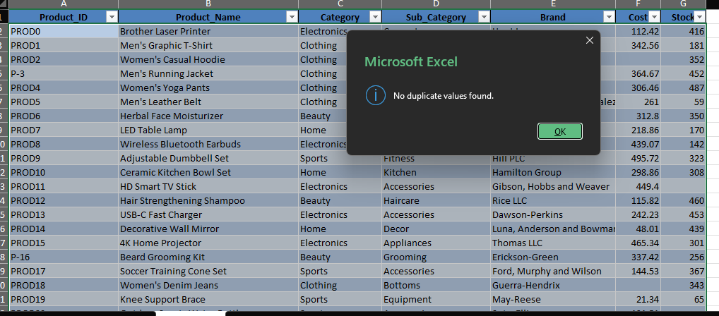

Handle missing

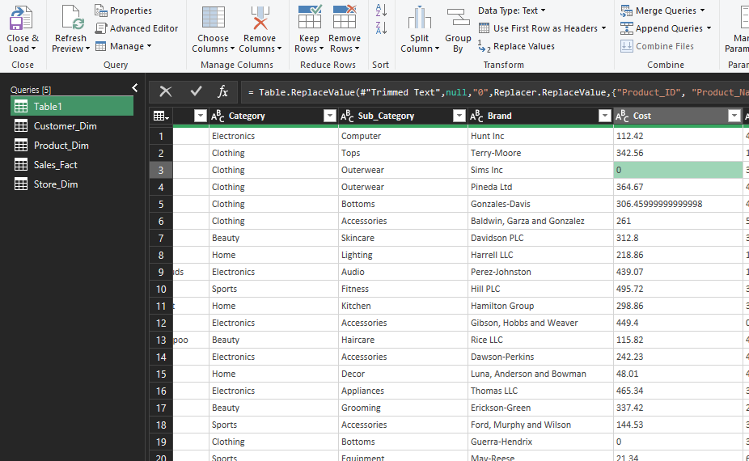

Missing value I replace the “0” in cost and stock column.

Inconsistent data

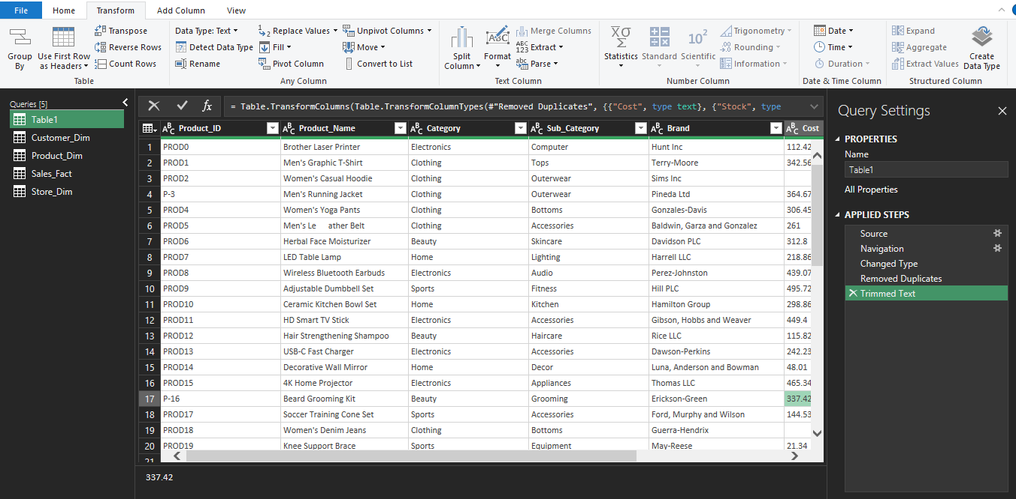

Inconsistent data I use trim function of all the columns.

correct formatting errors

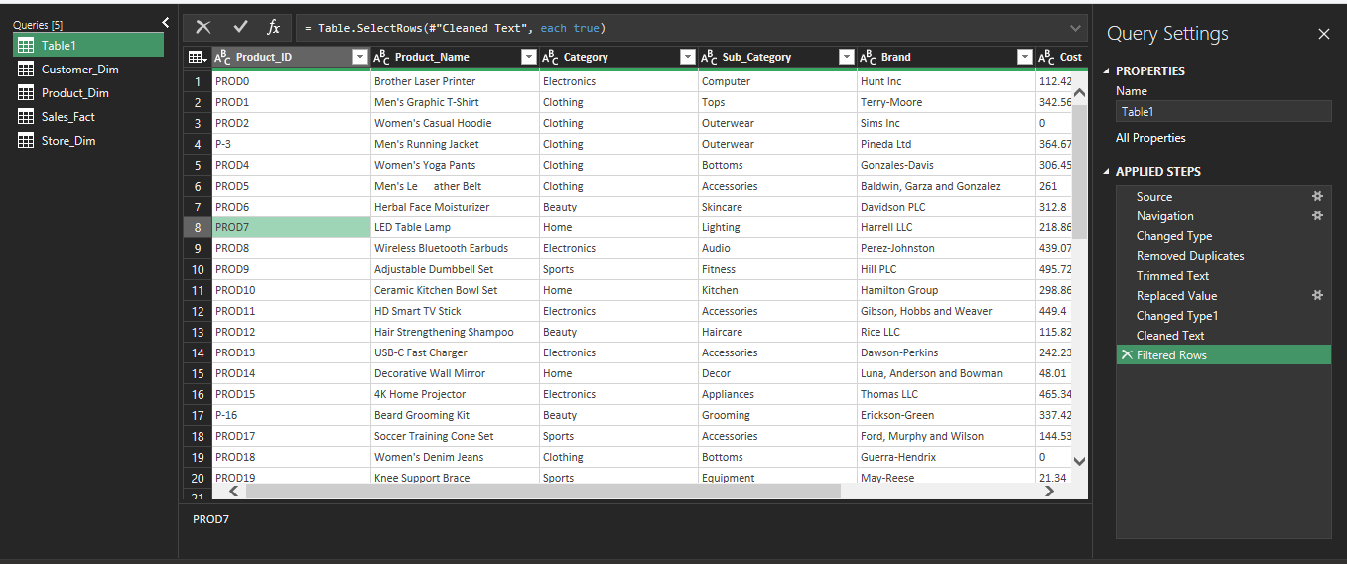

First I do change data type for all columns.

Then,

Text datatype I choose the capitalize each word format.

Number datatype I choose the whole number format.

Decimal datatype I choose the decimal number format.

Validate data

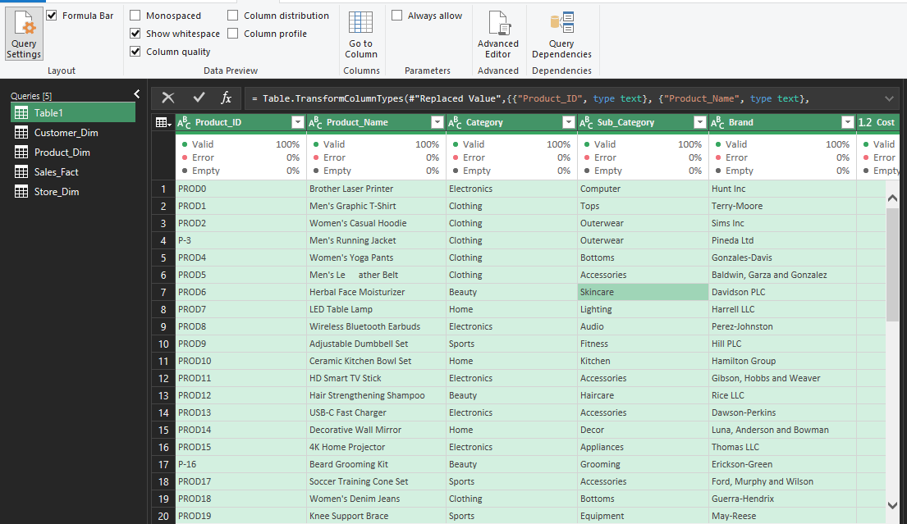

I use column quality column distribution, data type checks, and duplicate detection to identify missing values, errors, and duplicate records.

Go to view => column quality.

Remove the column that contains irrelevant data if it exists

I have 7 columns that are:

Product id

Product name

Category

Sub category

Brand

Cost

Stock

Which column are unnecessary for the project requirements so I decided to the sub category column to remove based on a project that analyse the product performance.

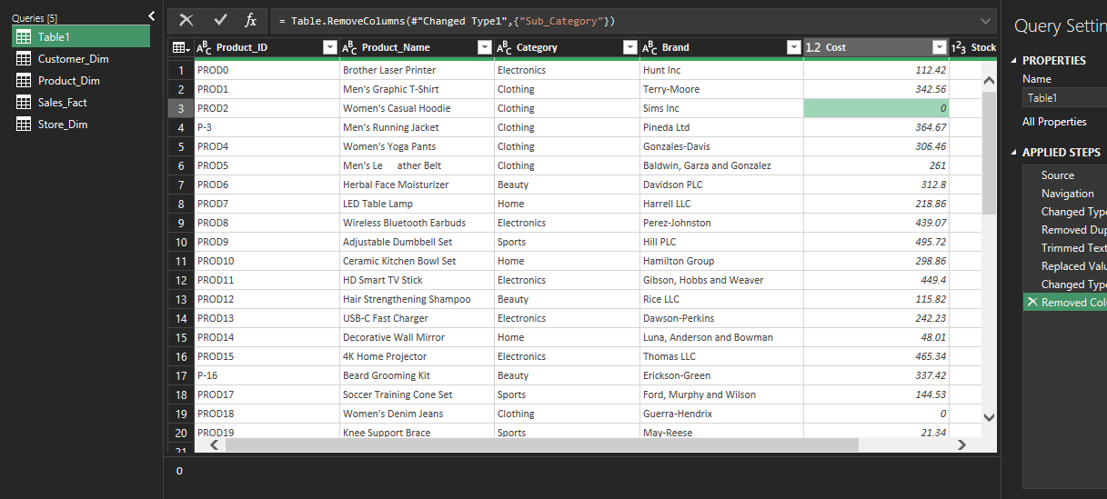

Application of Excel Formulas for Calculations, Summaries, and Logical/Text Operations

1. Calculation Formulas

These formulas perform basic mathematical operations on data.
Formula | Purpose | Example
=SUM() | Calculates the total | Total price
=AVERAGE() | Calculates the average | Average price
=MIN() | Finds the minimum value | Lowest price
=MAX() | Finds the maximum value | Highest price
=COUNT() | Counts numeric cells | Number of prices

2. Summary Formulas

These formulas help summarize and analyze data.
Formula | Purpose
=COUNTA() | Counts non-empty cells
=COUNTIF() | Counts products in Accessories
=SUMIF() | Adds prices for Electronics
=AVERAGEIF() | Calculates the average price of Electronics

3. Logical Formulas

Logical formulas check conditions and return results.
Formula | Purpose
=IF() | Classifies prices
=AND() | Checks whether both conditions are true
=OR() | Checks whether either condition is true
=IFERROR() | Returns 0 if the calculation produces an error

4. Text Formulas

Text formulas help extract, combine, and clean text.
Formula | Purpose
=LEFT() | Extracts the first 3 characters
=RIGHT() | Extracts the last 3 characters
=LEN() | Counts characters
=TRIM() | Removes extra spaces
=UPPER() | Converts text to uppercase
=LOWER() | Converts text to lowercase
=CONCAT() | Combines text from two cells

Descriptive Statistics in Excel

1. Excel formulas

Statistic | Excel formula | Meaning
Mean | =AVERAGE(F2:F101) | Average sales
Median | =MEDIAN(F2:F101) | Middle value
Mode | =MODE.SNGL(F2:F101) | Most frequently occurring value
Standard deviation | =STDEV.S(F2:F101) | How much values vary
Variance | =VAR.S(F2:F101) | Measure of data spread
Minimum | =MIN(F2:F101) | Lowest sales value
Maximum | =MAX(F2:F101) | Highest sales value
Count | =COUNT(F2:F101) | Number of numeric values
Sum | =SUM(F2:F101) | Total sales
Range | =MAX(F2:F101)-MIN(F2:F101) | Difference between maximum and minimum

Step apply:

Step 1: Enable Analysis ToolPak

File → Options → Add-ins → Manage Excel Add-ins → Go

Analysis ToolPak checkbox select panni OK click pannunga.

Step 2: Open Data Analysis

Data tab click pannunga. Right side-la Data Analysis select pannunga.

Step 3: Select Descriptive Statistics

Input Range: Sales_Fact!J1:J2001

Grouped By: Columns

Data visualization:

create at least three chart types, build an interactive dashboard, and use basic PivotCharts

